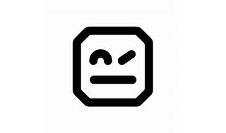

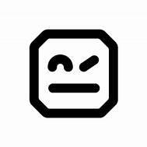

Explore

**Robot Framework** is a **generic open-source automation framework** used for **acceptance testing**, **acceptance test-driven development (ATDD)**, and **robotic process automation (RPA)**. It features a simple plain text syntax and can be extended with libraries implemented using Python or Java. [Robot Framework is operating system and application independent1](https://github.com/robotframework/robotframework)[2](https://robotframework.org/).

Here are **five free resources** where you can learn more about Robot Framework:

1. [**Robot Framework Official Website**](https://robotframework.org/): The official website provides comprehensive documentation, tutorials, and examples to get you started[2](https://robotframework.org/).
2. [**GitHub Repository**](https://github.com/robotframework/robotframework): Explore the source code, documentation, and issue tracker for Robot Framework on GitHub[1](https://github.com/robotframework/robotframework).
3. [**Robot Framework Cookbook**](https://github.com/adrianyorke/robotframework-cookbook): A curated list of Robot Framework resources, including guides, cheat sheets, and quick references[3](https://github.com/adrianyorke/robotframework-cookbook).
4. [**Class Central**](https://www.classcentral.com/subject/robot-framework): Discover free online courses related to Robot Framework on platforms like YouTube, Udemy, and LinkedIn Learning[4](https://www.classcentral.com/subject/robot-framework).
5. [**Test Automation University**](https://docs.robotframework.org/docs/getting_started/videos): This platform offers free video tutorials, including topics like web automation, mobile automation, and more[5](https://docs.robotframework.org/docs/getting_started/videos).

Happy learning! 🤖📚